CYB 300 Module Two Lab Worksheet One
Andree Salvo
Southern New Hampshire University
CYB 300
Instructor: Jason Keltner

Lab: Linux Scripting Techniques

Exercise 3: Create a Non-Interactive Script
Prompt | Response
Task 1: Create a “Hello, world!” Script: Provide a screenshot of Step 9 showing successful execution of the custom script. Add your name to the command line. | 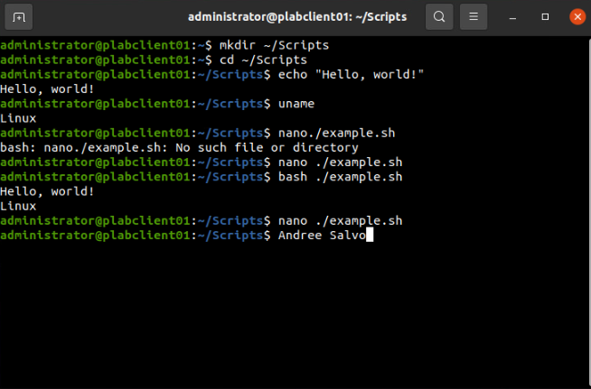
Task 2: Use Variables in a Script: Provide a screenshot of Step 4 showing successful execution of the custom script. Add your name to the command line. | 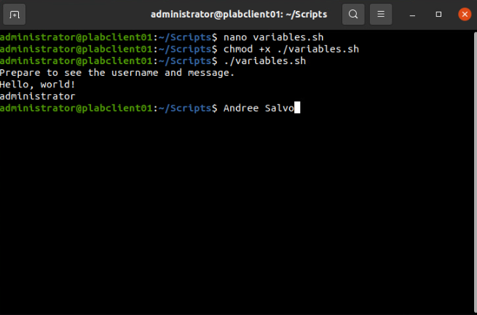

Exercise 4: Create an Interactive Script
Prompt | Response
Task 1: Create a Script That Requires User Input: Provide a screenshot of Step 4 showing successful execution of the custom script. Add your name to the command line. | 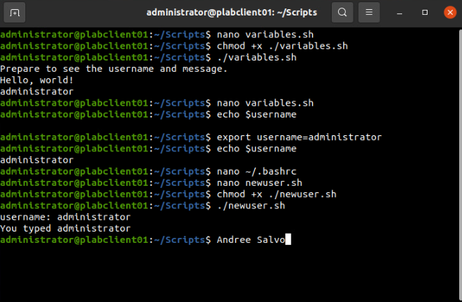

Exercise 5: Create Scripts Using Loops and Conditions
Prompt | Response
Task 1: Create Scripts Using Loops: Provide a screenshot of Step 4 showing successful creation of 10 videos in the “Videos” folder. Add your name to the command line. | 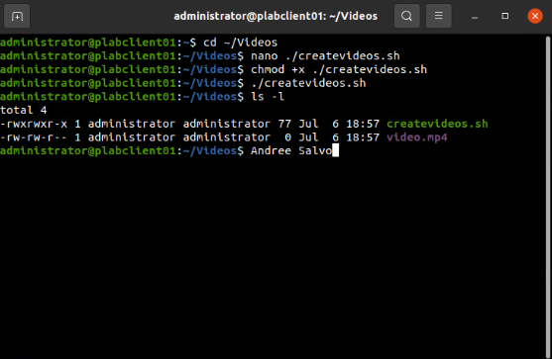
Task 2: Create Scripts Using Conditions and User Interaction: Provide a screenshot of Step 7 showing successful execution of the custom script. Add your name to the command line. | 